Shape of dataset (4366, 2)

Index(['Konten', 'Kelas'], dtype='object')

No. of unique classes 2

0 1

1 0

2 1

3 0

4 1

..

4361 0

4362 1

4363 1

4364 1

4365 1

Name: Kelas, Length: 4366, dtype: int64

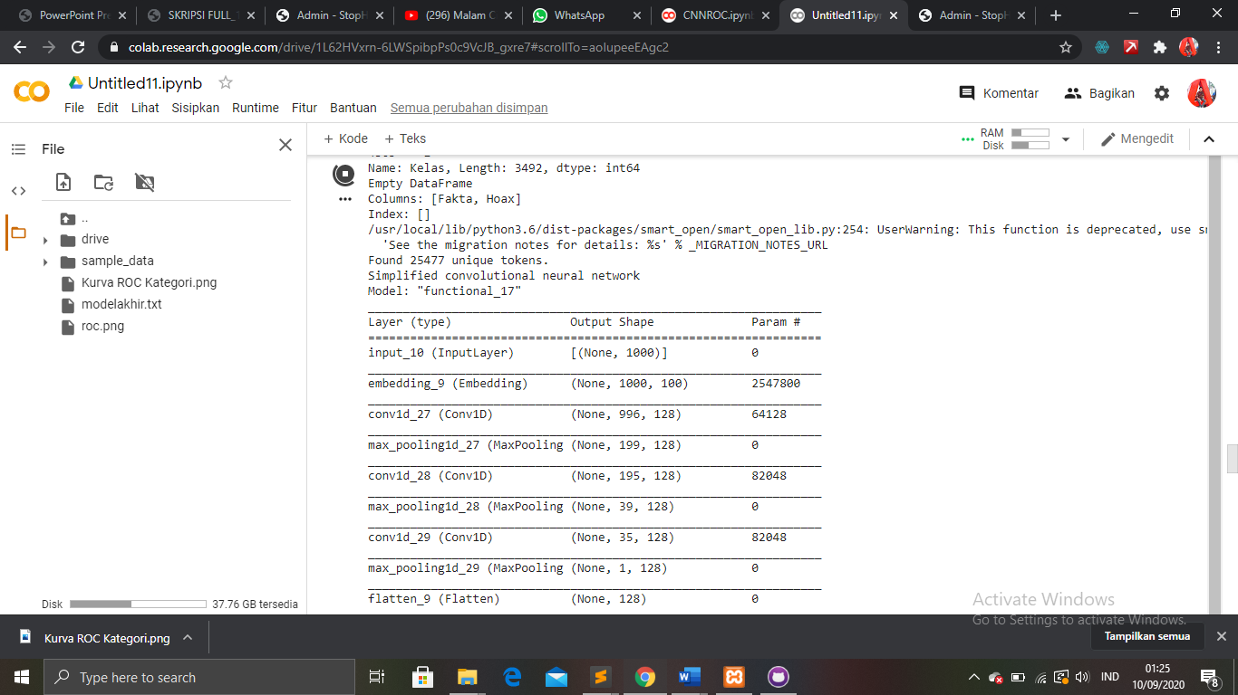 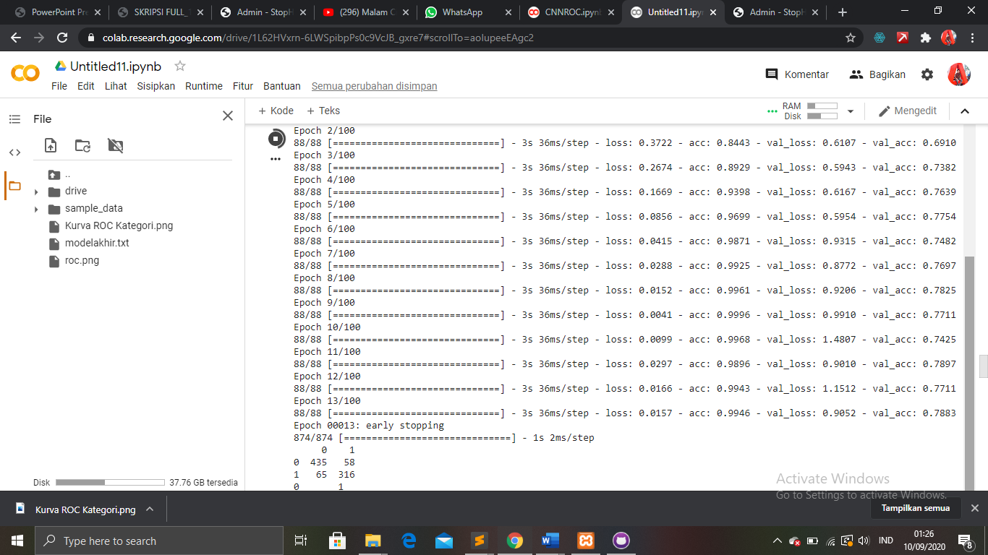

0 1

1 0

2 1

3 0

4 1

..

4361 0

4362 1

4363 1

4364 1

4365 1

Name: Kelas, Length: 3492, dtype: int64

Empty DataFrame

Columns: [Fakta, Hoax]

Index: []

/usr/local/lib/python3.6/dist-packages/smart_open/smart_open_lib.py:254: UserWarning: This function is deprecated, use smart_open.open instead. See the migration notes for details: <https://github.com/RaRe-Technologies/smart_open/blob/master/README.rst#migrating-to-the-new-open-function>

'See the migration notes for details: %s' % _MIGRATION_NOTES_URL

Found 25477 unique tokens.

Simplified convolutional neural network

Model: "functional_17"

_________________________________________________________________

Layer (type) Output Shape Param #

=================================================================

input_10 (InputLayer) [(None, 1000)] 0

_________________________________________________________________

embedding_9 (Embedding) (None, 1000, 100) 2547800

_________________________________________________________________

conv1d_27 (Conv1D) (None, 996, 128) 64128

_________________________________________________________________

max_pooling1d_27 (MaxPooling (None, 199, 128) 0

_________________________________________________________________

conv1d_28 (Conv1D) (None, 195, 128) 82048

_________________________________________________________________

max_pooling1d_28 (MaxPooling (None, 39, 128) 0

_________________________________________________________________

conv1d_29 (Conv1D) (None, 35, 128) 82048

_________________________________________________________________

max_pooling1d_29 (MaxPooling (None, 1, 128) 0

_________________________________________________________________

flatten_9 (Flatten) (None, 128) 0

_________________________________________________________________

dense_17 (Dense) (None, 128) 16512

_________________________________________________________________

dense_18 (Dense) (None, 2) 258

=================================================================

Total params: 2,792,794

Trainable params: 2,792,794

Non-trainable params: 0

_________________________________________________________________

Epoch 1/100

88/88 [==============================] - 3s 39ms/step - loss: 0.5363 - acc: 0.7651 - val_loss: 0.6534 - val_acc: 0.6624

Epoch 2/100

88/88 [==============================] - 3s 36ms/step - loss: 0.3722 - acc: 0.8443 - val_loss: 0.6107 - val_acc: 0.6910

Epoch 3/100

88/88 [==============================] - 3s 36ms/step - loss: 0.2674 - acc: 0.8929 - val_loss: 0.5943 - val_acc: 0.7382

Epoch 4/100

88/88 [==============================] - 3s 36ms/step - loss: 0.1669 - acc: 0.9398 - val_loss: 0.6167 - val_acc: 0.7639

Epoch 5/100

88/88 [==============================] - 3s 36ms/step - loss: 0.0856 - acc: 0.9699 - val_loss: 0.5954 - val_acc: 0.7754

Epoch 6/100

88/88 [==============================] - 3s 36ms/step - loss: 0.0415 - acc: 0.9871 - val_loss: 0.9315 - val_acc: 0.7482

Epoch 7/100

88/88 [==============================] - 3s 36ms/step - loss: 0.0288 - acc: 0.9925 - val_loss: 0.8772 - val_acc: 0.7697

Epoch 8/100

88/88 [==============================] - 3s 36ms/step - loss: 0.0152 - acc: 0.9961 - val_loss: 0.9206 - val_acc: 0.7825

Epoch 9/100

88/88 [==============================] - 3s 36ms/step - loss: 0.0041 - acc: 0.9996 - val_loss: 0.9910 - val_acc: 0.7711

Epoch 10/100

88/88 [==============================] - 3s 36ms/step - loss: 0.0099 - acc: 0.9968 - val_loss: 1.4807 - val_acc: 0.7425

Epoch 11/100

88/88 [==============================] - 3s 36ms/step - loss: 0.0297 - acc: 0.9896 - val_loss: 0.9010 - val_acc: 0.7897

Epoch 12/100

88/88 [==============================] - 3s 36ms/step - loss: 0.0166 - acc: 0.9943 - val_loss: 1.1512 - val_acc: 0.7711

Epoch 13/100

88/88 [==============================] - 3s 36ms/step - loss: 0.0157 - acc: 0.9946 - val_loss: 0.9052 - val_acc: 0.7883

Epoch 00013: early stopping

874/874 [==============================] - 1s 2ms/step

0 1

0 435 58

1 65 316

0 1

1 0

4 1

5 0

6 1

..

4358 1

4359 0

4360 1

4362 1

4363 1

Name: Kelas, Length: 3493, dtype: int64

Empty DataFrame

Columns: [Fakta, Hoax]

Index: []

/usr/local/lib/python3.6/dist-packages/ipykernel_launcher.py:143: DeprecationWarning: scipy.interp is deprecated and will be removed in SciPy 2.0.0, use numpy.interp instead

/usr/local/lib/python3.6/dist-packages/smart_open/smart_open_lib.py:254: UserWarning: This function is deprecated, use smart_open.open instead. See the migration notes for details: <https://github.com/RaRe-Technologies/smart_open/blob/master/README.rst#migrating-to-the-new-open-function>

'See the migration notes for details: %s' % _MIGRATION_NOTES_URL

/usr/local/lib/python3.6/dist-packages/ipykernel_launcher.py:35: SettingWithCopyWarning:

A value is trying to be set on a copy of a slice from a DataFrame

See the caveats in the documentation: <https://pandas.pydata.org/pandas-docs/stable/user_guide/indexing.html#returning-a-view-versus-a-copy>

Found 25595 unique tokens.

Simplified convolutional neural network

Model: "functional_19"

_________________________________________________________________

Layer (type) Output Shape Param #

=================================================================

input_11 (InputLayer) [(None, 1000)] 0

_________________________________________________________________

embedding_10 (Embedding) (None, 1000, 100) 2559600

_________________________________________________________________

conv1d_30 (Conv1D) (None, 996, 128) 64128

_________________________________________________________________

max_pooling1d_30 (MaxPooling (None, 199, 128) 0

_________________________________________________________________

conv1d_31 (Conv1D) (None, 195, 128) 82048

_________________________________________________________________

max_pooling1d_31 (MaxPooling (None, 39, 128) 0

_________________________________________________________________

conv1d_32 (Conv1D) (None, 35, 128) 82048

_________________________________________________________________

max_pooling1d_32 (MaxPooling (None, 1, 128) 0

_________________________________________________________________

flatten_10 (Flatten) (None, 128) 0

_________________________________________________________________

dense_19 (Dense) (None, 128) 16512

_________________________________________________________________

dense_20 (Dense) (None, 2) 258

=================================================================

Total params: 2,804,594

Trainable params: 2,804,594

Non-trainable params: 0

_________________________________________________________________

Epoch 1/100

88/88 [==============================] - 4s 40ms/step - loss: 0.5291 - acc: 0.7595 - val_loss: 0.6719 - val_acc: 0.6695

Epoch 2/100

88/88 [==============================] - 3s 38ms/step - loss: 0.4206 - acc: 0.8264 - val_loss: 0.5815 - val_acc: 0.6881

Epoch 3/100

88/88 [==============================] - 3s 37ms/step - loss: 0.2975 - acc: 0.8776 - val_loss: 0.4943 - val_acc: 0.7811

Epoch 4/100

88/88 [==============================] - 3s 37ms/step - loss: 0.1794 - acc: 0.9234 - val_loss: 0.5031 - val_acc: 0.7868

Epoch 5/100

88/88 [==============================] - 3s 37ms/step - loss: 0.1075 - acc: 0.9610 - val_loss: 0.5683 - val_acc: 0.7940

Epoch 6/100

88/88 [==============================] - 3s 37ms/step - loss: 0.0879 - acc: 0.9678 - val_loss: 0.5395 - val_acc: 0.7911

Epoch 7/100

88/88 [==============================] - 3s 37ms/step - loss: 0.0428 - acc: 0.9850 - val_loss: 0.8702 - val_acc: 0.7568

Epoch 8/100

88/88 [==============================] - 3s 38ms/step - loss: 0.0189 - acc: 0.9943 - val_loss: 0.7440 - val_acc: 0.7854

Epoch 9/100

88/88 [==============================] - 3s 37ms/step - loss: 0.0077 - acc: 0.9975 - val_loss: 0.8727 - val_acc: 0.7754

Epoch 10/100

88/88 [==============================] - 3s 38ms/step - loss: 0.0031 - acc: 0.9996 - val_loss: 0.9219 - val_acc: 0.7783

Epoch 11/100

88/88 [==============================] - 3s 37ms/step - loss: 7.6225e-04 - acc: 1.0000 - val_loss: 0.9984 - val_acc: 0.7725

Epoch 12/100

88/88 [==============================] - 3s 37ms/step - loss: 2.8822e-04 - acc: 1.0000 - val_loss: 1.0662 - val_acc: 0.7725

Epoch 13/100

88/88 [==============================] - 3s 38ms/step - loss: 1.3649e-04 - acc: 1.0000 - val_loss: 1.1270 - val_acc: 0.7783

Epoch 00013: early stopping

873/873 [==============================] - 1s 2ms/step

0 1

0 435 57

1 62 319

1 0

2 1

3 0

5 0

6 1

..

4361 0

4362 1

4363 1

4364 1

4365 1

Name: Kelas, Length: 3493, dtype: int64

Empty DataFrame

Columns: [Fakta, Hoax]

Index: []

/usr/local/lib/python3.6/dist-packages/ipykernel_launcher.py:143: DeprecationWarning: scipy.interp is deprecated and will be removed in SciPy 2.0.0, use numpy.interp instead

/usr/local/lib/python3.6/dist-packages/smart_open/smart_open_lib.py:254: UserWarning: This function is deprecated, use smart_open.open instead. See the migration notes for details: <https://github.com/RaRe-Technologies/smart_open/blob/master/README.rst#migrating-to-the-new-open-function>

'See the migration notes for details: %s' % _MIGRATION_NOTES_URL

/usr/local/lib/python3.6/dist-packages/ipykernel_launcher.py:35: SettingWithCopyWarning:

A value is trying to be set on a copy of a slice from a DataFrame

See the caveats in the documentation: <https://pandas.pydata.org/pandas-docs/stable/user_guide/indexing.html#returning-a-view-versus-a-copy>

Found 25607 unique tokens.

Simplified convolutional neural network

Model: "functional_21"

_________________________________________________________________

Layer (type) Output Shape Param #

=================================================================

input_12 (InputLayer) [(None, 1000)] 0

_________________________________________________________________

embedding_11 (Embedding) (None, 1000, 100) 2560800

_________________________________________________________________

conv1d_33 (Conv1D) (None, 996, 128) 64128

_________________________________________________________________

max_pooling1d_33 (MaxPooling (None, 199, 128) 0

_________________________________________________________________

conv1d_34 (Conv1D) (None, 195, 128) 82048

_________________________________________________________________

max_pooling1d_34 (MaxPooling (None, 39, 128) 0

_________________________________________________________________

conv1d_35 (Conv1D) (None, 35, 128) 82048

_________________________________________________________________

max_pooling1d_35 (MaxPooling (None, 1, 128) 0

_________________________________________________________________

flatten_11 (Flatten) (None, 128) 0

_________________________________________________________________

dense_21 (Dense) (None, 128) 16512

_________________________________________________________________

dense_22 (Dense) (None, 2) 258

=================================================================

Total params: 2,805,794

Trainable params: 2,805,794

Non-trainable params: 0

_________________________________________________________________

Epoch 1/100

88/88 [==============================] - 3s 40ms/step - loss: 0.5138 - acc: 0.7656 - val_loss: 0.6294 - val_acc: 0.6795

Epoch 2/100

88/88 [==============================] - 3s 36ms/step - loss: 0.3327 - acc: 0.8644 - val_loss: 0.5651 - val_acc: 0.7082

Epoch 3/100

88/88 [==============================] - 3s 36ms/step - loss: 0.2119 - acc: 0.9198 - val_loss: 0.4990 - val_acc: 0.7611

Epoch 4/100

88/88 [==============================] - 3s 36ms/step - loss: 0.1197 - acc: 0.9613 - val_loss: 0.5234 - val_acc: 0.7868

Epoch 5/100

88/88 [==============================] - 3s 37ms/step - loss: 0.1060 - acc: 0.9656 - val_loss: 0.4891 - val_acc: 0.7969

Epoch 6/100

88/88 [==============================] - 3s 37ms/step - loss: 0.0471 - acc: 0.9871 - val_loss: 0.6688 - val_acc: 0.7897

Epoch 7/100

88/88 [==============================] - 3s 36ms/step - loss: 0.0359 - acc: 0.9903 - val_loss: 0.7286 - val_acc: 0.8112

Epoch 8/100

88/88 [==============================] - 3s 36ms/step - loss: 0.0230 - acc: 0.9950 - val_loss: 1.1121 - val_acc: 0.7668

Epoch 9/100

88/88 [==============================] - 3s 37ms/step - loss: 0.0126 - acc: 0.9986 - val_loss: 1.8946 - val_acc: 0.7110

Epoch 10/100

88/88 [==============================] - 3s 37ms/step - loss: 0.0206 - acc: 0.9943 - val_loss: 0.8763 - val_acc: 0.7911

Epoch 11/100

88/88 [==============================] - 3s 36ms/step - loss: 0.0264 - acc: 0.9943 - val_loss: 0.8649 - val_acc: 0.7926

Epoch 12/100

88/88 [==============================] - 3s 36ms/step - loss: 0.0073 - acc: 0.9996 - val_loss: 1.2251 - val_acc: 0.7783

Epoch 13/100

88/88 [==============================] - 3s 36ms/step - loss: 0.0061 - acc: 0.9996 - val_loss: 1.1208 - val_acc: 0.7926

Epoch 14/100

88/88 [==============================] - 3s 36ms/step - loss: 0.0058 - acc: 0.9996 - val_loss: 1.1334 - val_acc: 0.7940

Epoch 15/100

88/88 [==============================] - 3s 37ms/step - loss: 0.0057 - acc: 0.9996 - val_loss: 1.1885 - val_acc: 0.7926

Epoch 00015: early stopping

873/873 [==============================] - 1s 2ms/step

0 1

0 420 73

1 45 335

0 1

1 0

2 1

3 0

4 1

..

4360 1

4361 0

4363 1

4364 1

4365 1

Name: Kelas, Length: 3493, dtype: int64

Empty DataFrame

Columns: [Fakta, Hoax]

Index: []

/usr/local/lib/python3.6/dist-packages/ipykernel_launcher.py:143: DeprecationWarning: scipy.interp is deprecated and will be removed in SciPy 2.0.0, use numpy.interp instead

/usr/local/lib/python3.6/dist-packages/smart_open/smart_open_lib.py:254: UserWarning: This function is deprecated, use smart_open.open instead. See the migration notes for details: <https://github.com/RaRe-Technologies/smart_open/blob/master/README.rst#migrating-to-the-new-open-function>

'See the migration notes for details: %s' % _MIGRATION_NOTES_URL

/usr/local/lib/python3.6/dist-packages/ipykernel_launcher.py:35: SettingWithCopyWarning:

A value is trying to be set on a copy of a slice from a DataFrame

See the caveats in the documentation: <https://pandas.pydata.org/pandas-docs/stable/user_guide/indexing.html#returning-a-view-versus-a-copy>

Found 25622 unique tokens.

Simplified convolutional neural network

Model: "functional_23"

_________________________________________________________________

Layer (type) Output Shape Param #

=================================================================

input_13 (InputLayer) [(None, 1000)] 0

_________________________________________________________________

embedding_12 (Embedding) (None, 1000, 100) 2562300

_________________________________________________________________

conv1d_36 (Conv1D) (None, 996, 128) 64128

_________________________________________________________________

max_pooling1d_36 (MaxPooling (None, 199, 128) 0

_________________________________________________________________

conv1d_37 (Conv1D) (None, 195, 128) 82048

_________________________________________________________________

max_pooling1d_37 (MaxPooling (None, 39, 128) 0

_________________________________________________________________

conv1d_38 (Conv1D) (None, 35, 128) 82048

_________________________________________________________________

max_pooling1d_38 (MaxPooling (None, 1, 128) 0

_________________________________________________________________

flatten_12 (Flatten) (None, 128) 0

_________________________________________________________________

dense_23 (Dense) (None, 128) 16512

_________________________________________________________________

dense_24 (Dense) (None, 2) 258

=================================================================

Total params: 2,807,294

Trainable params: 2,807,294

Non-trainable params: 0

_________________________________________________________________

Epoch 1/100

88/88 [==============================] - 4s 40ms/step - loss: 0.5242 - acc: 0.7752 - val_loss: 0.6354 - val_acc: 0.6652

Epoch 2/100

88/88 [==============================] - 3s 37ms/step - loss: 0.3660 - acc: 0.8515 - val_loss: 0.6063 - val_acc: 0.6996

Epoch 3/100

88/88 [==============================] - 3s 37ms/step - loss: 0.2334 - acc: 0.9105 - val_loss: 0.5690 - val_acc: 0.7310

Epoch 4/100

88/88 [==============================] - 3s 37ms/step - loss: 0.1316 - acc: 0.9545 - val_loss: 0.5462 - val_acc: 0.7926

Epoch 5/100

88/88 [==============================] - 3s 36ms/step - loss: 0.0628 - acc: 0.9821 - val_loss: 0.7879 - val_acc: 0.7554

Epoch 6/100

88/88 [==============================] - 3s 37ms/step - loss: 0.0319 - acc: 0.9911 - val_loss: 0.7493 - val_acc: 0.7811

Epoch 7/100

88/88 [==============================] - 3s 38ms/step - loss: 0.0147 - acc: 0.9971 - val_loss: 0.9819 - val_acc: 0.7353

Epoch 8/100

88/88 [==============================] - 3s 37ms/step - loss: 0.0099 - acc: 0.9975 - val_loss: 0.9901 - val_acc: 0.7682

Epoch 9/100

88/88 [==============================] - 3s 36ms/step - loss: 0.0027 - acc: 0.9996 - val_loss: 1.0088 - val_acc: 0.7740

Epoch 10/100

88/88 [==============================] - 3s 37ms/step - loss: 0.0010 - acc: 1.0000 - val_loss: 1.1623 - val_acc: 0.7797

Epoch 11/100

88/88 [==============================] - 3s 38ms/step - loss: 4.5872e-04 - acc: 1.0000 - val_loss: 1.1600 - val_acc: 0.7840

Epoch 12/100

88/88 [==============================] - 3s 37ms/step - loss: 2.3132e-04 - acc: 1.0000 - val_loss: 1.2060 - val_acc: 0.7854

Epoch 13/100

88/88 [==============================] - 3s 38ms/step - loss: 1.3945e-04 - acc: 1.0000 - val_loss: 1.2430 - val_acc: 0.7883

Epoch 14/100

88/88 [==============================] - 3s 37ms/step - loss: 9.3325e-05 - acc: 1.0000 - val_loss: 1.2617 - val_acc: 0.7840

Epoch 00014: early stopping

873/873 [==============================] - 1s 2ms/step

0 1

0 435 58

1 68 312

0 1

2 1

3 0

4 1

6 1

..

4360 1

4361 0

4362 1

4364 1

4365 1

Name: Kelas, Length: 3493, dtype: int64

Empty DataFrame

Columns: [Fakta, Hoax]

Index: []

/usr/local/lib/python3.6/dist-packages/ipykernel_launcher.py:143: DeprecationWarning: scipy.interp is deprecated and will be removed in SciPy 2.0.0, use numpy.interp instead

/usr/local/lib/python3.6/dist-packages/smart_open/smart_open_lib.py:254: UserWarning: This function is deprecated, use smart_open.open instead. See the migration notes for details: <https://github.com/RaRe-Technologies/smart_open/blob/master/README.rst#migrating-to-the-new-open-function>

'See the migration notes for details: %s' % _MIGRATION_NOTES_URL

/usr/local/lib/python3.6/dist-packages/ipykernel_launcher.py:35: SettingWithCopyWarning:

A value is trying to be set on a copy of a slice from a DataFrame

See the caveats in the documentation: <https://pandas.pydata.org/pandas-docs/stable/user_guide/indexing.html#returning-a-view-versus-a-copy>

Found 25873 unique tokens.

Simplified convolutional neural network

Model: "functional_25"

_________________________________________________________________

Layer (type) Output Shape Param #

=================================================================

input_14 (InputLayer) [(None, 1000)] 0

_________________________________________________________________

embedding_13 (Embedding) (None, 1000, 100) 2587400

_________________________________________________________________

conv1d_39 (Conv1D) (None, 996, 128) 64128

_________________________________________________________________

max_pooling1d_39 (MaxPooling (None, 199, 128) 0

_________________________________________________________________

conv1d_40 (Conv1D) (None, 195, 128) 82048

_________________________________________________________________

max_pooling1d_40 (MaxPooling (None, 39, 128) 0

_________________________________________________________________

conv1d_41 (Conv1D) (None, 35, 128) 82048

_________________________________________________________________

max_pooling1d_41 (MaxPooling (None, 1, 128) 0

_________________________________________________________________

flatten_13 (Flatten) (None, 128) 0

_________________________________________________________________

dense_25 (Dense) (None, 128) 16512

_________________________________________________________________

dense_26 (Dense) (None, 2) 258

=================================================================

Total params: 2,832,394

Trainable params: 2,832,394

Non-trainable params: 0

_________________________________________________________________

Epoch 1/100

88/88 [==============================] - 4s 42ms/step - loss: 0.5332 - acc: 0.7609 - val_loss: 0.7446 - val_acc: 0.6423

Epoch 2/100

88/88 [==============================] - 3s 40ms/step - loss: 0.3761 - acc: 0.8429 - val_loss: 0.7763 - val_acc: 0.6953

Epoch 3/100

88/88 [==============================] - 3s 39ms/step - loss: 0.2316 - acc: 0.9062 - val_loss: 0.6709 - val_acc: 0.7167

Epoch 4/100

88/88 [==============================] - 4s 40ms/step - loss: 0.1304 - acc: 0.9542 - val_loss: 0.6511 - val_acc: 0.7554

Epoch 5/100

88/88 [==============================] - 4s 40ms/step - loss: 0.0578 - acc: 0.9835 - val_loss: 0.9763 - val_acc: 0.7511

Epoch 6/100

88/88 [==============================] - 3s 39ms/step - loss: 0.0363 - acc: 0.9918 - val_loss: 0.7160 - val_acc: 0.7940

Epoch 7/100

88/88 [==============================] - 4s 40ms/step - loss: 0.0376 - acc: 0.9882 - val_loss: 0.8328 - val_acc: 0.7568

Epoch 8/100

88/88 [==============================] - 3s 38ms/step - loss: 0.0435 - acc: 0.9846 - val_loss: 0.6977 - val_acc: 0.7983

Epoch 9/100

88/88 [==============================] - 3s 39ms/step - loss: 0.0112 - acc: 0.9979 - val_loss: 0.9741 - val_acc: 0.8040

Epoch 10/100

88/88 [==============================] - 4s 40ms/step - loss: 0.0075 - acc: 0.9996 - val_loss: 1.3113 - val_acc: 0.7768

Epoch 11/100

88/88 [==============================] - 4s 40ms/step - loss: 0.0060 - acc: 0.9996 - val_loss: 1.2139 - val_acc: 0.8011

Epoch 12/100

88/88 [==============================] - 3s 39ms/step - loss: 0.0057 - acc: 0.9996 - val_loss: 1.2633 - val_acc: 0.7926

Epoch 13/100

88/88 [==============================] - 3s 38ms/step - loss: 0.0056 - acc: 0.9996 - val_loss: 1.3067 - val_acc: 0.7954

Epoch 14/100

88/88 [==============================] - 3s 38ms/step - loss: 0.0055 - acc: 0.9996 - val_loss: 1.3370 - val_acc: 0.7940

Epoch 00014: early stopping

873/873 [==============================] - 1s 2ms/step

0 1

0 441 52

1 49 331

/usr/local/lib/python3.6/dist-packages/ipykernel_launcher.py:143: DeprecationWarning: scipy.interp is deprecated and will be removed in SciPy 2.0.0, use numpy.interp instead

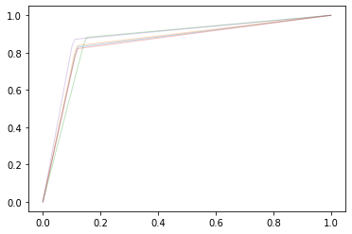

print(acc)

print(presisi)

print(recal)

[0.8592677345537757, 0.86368843069874, 0.8648339060710195, 0.8556701030927835, 0.8843069873997709]

[0.8574598930481283, 0.8618278821867374, 0.8621521189120809, 0.8540271882220193, 0.8821148825065275]

[0.8558746333178942, 0.8607083413353819, 0.8667529625280239, 0.8517027863777089, 0.8827879790754778]

print(sum(acc)/len(acc))

print(sum(presisi)/len(presisi))

print(sum(recal)/len(recal))

0.8655534323632178

0.8635163929750986

0.8635653405268974